*Software Quality Engineering – Assignment No.3:*

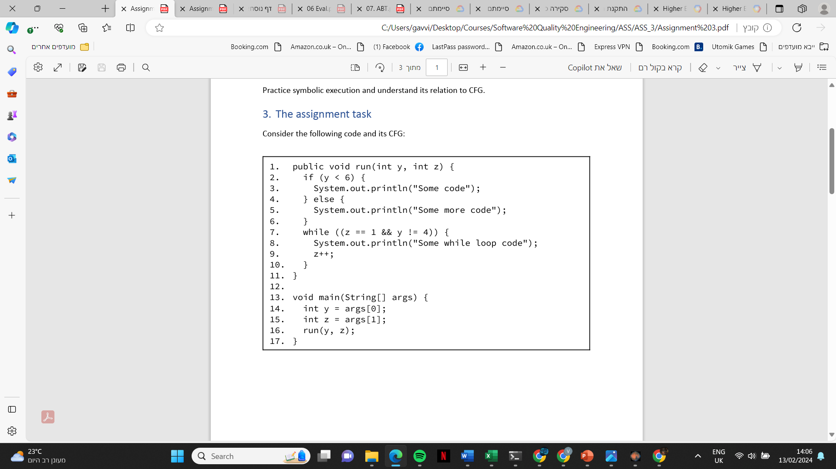

|  |  |  |
| --- | --- | --- |
| PCT | Symbolic Store | At The End of Row |
| True |  | 15 |
|  | [15] | 2 |
| [2] | [15] | 5 |
|  | [15] |  |
|  | [15] | 11 |

|  |  |  |
| --- | --- | --- |
| PCT | Symbolic Store | At The End of Row |
| True |  | 15 |
|  | [15] | 2 |
| [2] | [15] | 3 |
|  | [15] |  |
|  | [15] |  |
|  |  |  |
|  | [ |  |
|  |  | 11 |

|  |  |  |
| --- | --- | --- |
| PCT | Symbolic Store | At The End of Row |
| True |  | 15 |
|  | [15] | 2 |
| [2] | [15] | 3 |
|  | [15] |  |
|  | [15] |  |
|  |  |  |
|  | [ |  |
|  |  | 11 |

|  |  |  |
| --- | --- | --- |
| PCT | Symbolic Store | At The End of Row |
| True |  | 15 |
|  | [15] | 2 |
| [2] | [15] | 5 |
|  | [15] |  |
|  | [15] | 11 |